S w

907D18

NISSAN CANADA INC.

Kyle Hunter wrote this case under the supervision of Professor P. Fraser Johnson solely to provide material for class discussion. The authors do not intend to illustrate either effective or ineffective handling of a managerial situation. The authors may have disguised certain names and other identifying information to protect confidentiality.

Ivey Management Services prohibits any form of reproduction, storage or transmittal without its written permission. Reproduction of this material is not covered under authorization by any reproduction rights organization. To order copies or request permission to reproduce materials, contact Ivey Publishing, Ivey Management Services, c/o Richard Ivey School of Business, The University of Western Ontario, London, Ontario, Canada, N6A 3K7; phone (519) 661-3208; fax (519) 661-3882; e-mail cases@ivey.uwo.ca.

Copyright © 2007, Ivey Management Services Version: 2007-08-28

Dave Richardson, corporate manager of vehicle planning at Nissan Canada Inc. (NCI), located in Mississauga, Ontario, had been asked by Eric Caldwell, director of vehicle ordering for Nissan North America (NNA), to review the proposed vehicle ordering process as part of the new Integrated Customer Order Network (ICON). The ICON project would change Nissan’s North American vehicle ordering process from a ‘make-to-stock’ into a ‘make-to-order’ environment, which called for a significant process transformation for Nissan’s operations in North America and Japan.

It was Monday, April 5, 2004, and Eric expected to meet with Dave the following week regarding the proposed changes. Dave was hoping that the new process would be exactly what the dealers and the sales organization were seeking in an effort to closer align production with customer demand. However, he needed to evaluate the new process from the perspective of all stakeholders (dealers, Nissan manufacturing operations and suppliers) to ensure that Nissan’s business objectives could be met.

THE NORTH AMERICAN AUTOMOTIVE INDUSTRY

The competitive landscape in the North American automotive industry had changed significantly in the past decade, with increased international competition (see Exhibit 1). In recent years, Toyota and Honda had gained market share in North America at the expense of General Motors (GM) and Ford. Exhibit 2 provides North American vehicle profitability data for the major car manufacturers in North America.

A major issue facing the industry was the ability of car manufacturers to address limited visibility of true customer demand. Specifically, it was estimated that one-half of Americans made compromises when buying cars by purchasing automobiles that would not have been their top choice if they had timely access to a wider range of product features and colours for the model that they intended to buy.1 Poor sales forecasts and the inability to react to changing customer preferences led to excess inventory and increased

1 Just-auto. Is BTO the auto industry’s answer to poor profitability? January 10, 2007. http://www.just- auto.com/article.aspx?id=86231&lk=s.

pressure on suppliers. As a result, the industry used attractive financing options, heavy incentives, free upgrades and other inducements to sell surplus inventories of unwanted vehicles.

Recent economic developments had caused car manufacturers to focus more on internal cost cutting rather than on investing heavily in customer facing ‘make-to-order’ capabilities. As of 2002, only seven per cent of vehicles in the United States were make-to-order, versus approximately 19 per cent of cars in Europe, including 60 per cent in Germany and 32 per cent in the United Kingdom.2

NISSAN MOTOR CO., LTD.

Founded in 1933, Nissan Motor Co., Ltd. was Japan’s second largest car manufacturer. Trouble plagued the company in the early 1990s with high costs, unimaginative new product development, and $22 billion in debt. At this same time, French car manufacturer Renault was searching for an opportunity to penetrate the automobile market outside of Europe. In 1999, Renault purchased a 36.8 per cent equity stake in the company for US$5.4 billion, and Carlos Ghosn was named Nissan’s chief operating officer. Ghosn, who had been instrumental in turning around other struggling companies such as Michelin North America and Renault, instituted a “Revival Plan,” which included a number of aggressive cost-cutting objectives.

In one year, Nissan not only returned to profitability, but also the company posted its highest profits in corporate history (see Exhibits 3 and 4). In an effort to build on the success of the Nissan Revival Plan, Ghosn introduced the “Nissan 180 Plan,” which would set Nissan up for long-term, sustainable growth. The Nissan 180 Plan relied on four key components:

- Increasing revenue (through one million additional unit sales)
- Lowering costs (reducing costs 15 per cent over three years)
- Improving quality and speed (focusing on production and management)
- Maximizing benefits with the Renault alliance (finding synergies that benefit both)

Nissan Canada Inc. (NCI)

NCI had 170 dealerships, which were supported by a national sales office and three regional sales offices (eastern, western and Quebec). In 2003, NCI reported car and truck sales of 69,534, which accounted for a
4.3 per cent share of the Canadian market.

NCI’s national sales organization had been searching for opportunities to increase sales and market share, lower sales incentive rates and improve overall profitability. One major issue had been the absence of a robust forecasting tool, which led to excess vehicle inventories that could be sold only by using significant sales incentives. Management believed that improvements to the ordering process would result in an improvement of the model-mix of on-hand inventory.

Nissan car dealerships were owned and operated independently of NCI. Long lead times were a concern to dealers, who wanted to have the ability to customize a vehicle to the particular interests and needs of their customers on a timely basis.

Dave Richardson joined NCI in 1987 and had worked in various departments during that time, including finance, logistics, dealer operations, fleet, and customer satisfaction. Dave had been the corporate manager

2 Source: company records.

for vehicle planning for the last three years, and the ICON project would be the first major process transformation undertaken by his department.

CURRENT VEHICLE ORDERING PROCESS

Nissan was able to produce a wide range of vehicle combinations. For example, the Altima could be produced in more than 650 vehicle combinations (e.g., power train options, body type and luxury packages, etc.), nine exterior colours and three interior colours. NCI’s national sales office determined the number of vehicle combinations and exterior and interior colours that were offered to the Canadian market, where, for example, there were 20 Altima vehicle combinations, eight exterior colours and three interior colours available to order. The dealers depended on the national sales office to gauge consumer demand and current trends in the market.

There were six distinct steps in NCI’s vehicle ordering process from the time that a customer placed a vehicle order with a dealer to the time that the vehicle arrived at the dealership. These steps, with average time in parentheses, included: customer order entry (five days), order acceptance (15 days), order scheduling (23 days), order sequencing (two days), manufacturing (five days) and logistics (10 days). In total, the customer ordering lead time was approximately 60 days (see Exhibit 5).

For a given production month, the vehicle ordering process began with the NCI sales organization submitting a vehicle order forecast to the manufacturing plants in North America and Japan three months prior to production. Using Excel spreadsheets, the vehicle planning analyst would split the production volume, established by the plant, into volume for each of the three regions based on sales rate and existing inventory. The volume allocation would be communicated by e-mail to the three regions.

Each region would then allocate the volume by car model to its dealers and communicate this allocation back to the sales office. The sales office would then send an electronic report to each of the dealers, indicating the number of each car model they have been allocated for the coming production month. In turn, dealers would choose the model-mix (vehicle combination, exterior colour and interior colour) they wanted for each car model and would electronically send these orders back to the sales office 60 days prior to production. In most cases, dealer requests were accommodated unless there was a restriction on the allocation of the model.

Anytime following allocation, dealers could submit order modification requests to the vehicle planning analyst by phone, e-mail or fax. The change requests would be accumulated by the vehicle planning analyst, and the order attributes would be checked against production constraints 14 days prior to production. Consequently, dealers could be forced to wait up to 46 days to receive a response regarding change requests. Orders were frozen by the plant 14 days prior to production.

INTEGRATED CUSTOMER ORDER NETWORK PROJECT

As a result of the competitive challenges occurring in the automotive market in North America, Nissan introduced the innovative Integrated Customer Order Network (ICON). The ICON project was developed as part of the ‘Nissan 180’ program and was in response to three key imperatives:

- Shift to a more customer-centric (pull model) focus supporting increased customer demands;
- Alignment of core practices and processes to Nissan’s Global Brand Initiative; and

- Support Nissan goals of:
  - Increased revenue
  - Lower costs
  - Higher customer satisfaction
  - Reduced lead times
  - Lower finished goods inventory
  - Maximize synergies with Renault

NCI estimated the ICON project would be implemented over an 18-month period at a cost of approximately $6.5 million.

The New Vehicle Ordering Process

The thought of manufacturing vehicles based on actual customer demand did not seem possible, given the long supplier lead times and associated costs in procuring those parts. However, the ICON vehicle ordering process would drastically change the way NNA and NCI sales organizations, manufacturing plants and the dealerships interacted. The proposed vehicle ordering process would consist of monthly, weekly and daily ordering. Dave believed the concept of ICON could transform the automotive industry:

ICON will allow us to capture exact dealer orders, on short notice, and align our supply chain accordingly to have the right car in the right place at the right time. Our dealers will be able to close sales faster and more efficiently.

The Monthly and Weekly Ordering Process

Under the new process, NCI and the other North American sales organizations would continue to submit a vehicle order forecast to the manufacturing plants three months prior to production. The plants would continue to use this forecast to procure parts from its suppliers for the forecasted production month. However, the sales organizations would use Manugistics planning tools, demand planning and demand fulfilment, to more accurately predict customer demand, at the model-mix level, for the forecast production month. Refer to Exhibit 6 for a description of Manugistics’ tools.

The demand planning tool would provide a demand forecast at the individual dealer level, and this forecast would then be used as an input into the demand fulfilment tool. Using the demand fulfilment tool, the vehicle planning analyst would be able to calculate the net requirement for the forecast production month at the national level, taking into account the inventory days of supply at the dealer and regional compounds and the scheduled production for the next two production months. A pictorial of this process is illustrated in Exhibit 7.

The manufacturing plants would use the forecast from each of the sales organizations to procure parts for production. Based on the model-mix forecast, the plants would then provide each sales organization with a restriction of 15 per cent to 20 per cent by car model, option package and colour, to which the sales organization would have to adhere during the ordering process as they moved closer to production.

The weekly ordering process would begin one month prior to the production month. Repeating steps similar to the monthly ordering process, the vehicle planning analyst would utilize the demand planning and demand fulfilment tools to create a net vehicle requirement at the individual dealer level for the

upcoming production month. However, this set of vehicle orders would have to be scheduled using Manugistics’ attribute-based planning tool within the weekly option-package and colour restrictions provided by the plant. Any vehicle orders that could not be scheduled within the plant-provided restrictions would have to be substituted for a model with a different option package or colour by the vehicle planning analyst.

The new order-management system would then present the vehicle orders to each of the dealers as an order set as recommended by the national sales office. Dealers would have the option to accept, reject or modify any of the vehicle orders. The vehicle planning analyst would then attempt to schedule the modified orders within the plant-provided restrictions. Any vehicle orders that could not be scheduled within the restrictions would be substituted and sent back to the dealers, who would have the option to accept or reject them.

The final dealer order set, scheduled in weeks, would be sent to each of the manufacturing plants by the vehicle planning analyst. Using the new order management system, dealers would be able to submit online change requests for any order in the upcoming production month. Order change requests would be checked against the option-package and colour restrictions provided by the plant, and dealers would receive a response back in real-time. Dealers would be able to attempt to change any of their orders up to six days prior to production, after which the order would be ‘frozen’ by the manufacturing plant for production.

Dave commented on the practical implications of the changes:

My first concern is that the new process will give the national sales organization control over the production schedule, which might make the dealers feel uncomfortable. The dealers may believe that they have a better understanding of customer needs in their local market. In addition, they are ultimately responsible for selling the vehicles and turning a profit at the dealership. They may not like the fact that the national sales office is recommending vehicle orders to them. In the new process, dealers may not be able to receive all of their selections one month before production, even though they likely would have received all of their selections three months prior to production in the current process.

My second concern relates to the capabilities of our supply chain. Currently, our assembly plants and suppliers receive firm orders three months in advance. However, under the new system, we will be expecting the plants and suppliers to accommodate as much as a 20 per cent change in volumes on our option packages. This is a huge change, and I don’t want to see our costs increase as a result. We need to consider how to address implementation with our assembly plants and suppliers before proceeding.

Process Benefits

NCI’s dealers were closing sales at a rate of 26 per cent, and it was estimated that ICON would help dealers improve the close rate to 27 per cent.3 It was expected that the improved close rate would be realized gradually during the first two years as the stakeholders became more comfortable. Consequently, NCI expected the close rate to reach 26.3 per cent in 2006, 26.6 per cent in 2007, and 27 per cent by 2008.

3 Company records.

NCI’s inventory consisted of vehicles held at the regional compounds and in-transit inventory. It was estimated that NCI could reduce its inventory at its regional compounds, which would amount to an overall reduction in days of supply from 24 days to 20 days.

PROCESS SIGN-OFF

Dave knew that his meeting with Eric was the following week, and he wanted to take the time to evaluate the new process. Specifically, before proceeding with the new, centralized-order planning process, Dave wanted to assess the supply chain impact, including the potential financial benefits and implementation issues:

I want to be able to present a solid business case for proceeding, which means understanding the financial implications. Consequently, I will first need to carefully assess the potential costs and benefits before proceeding.

Second, I also need to develop an implementation plan. Assuming that all of our supply chain partners – dealers, assembly plants and suppliers – would benefit from increased market share, the question then becomes getting buy-in and understanding the changes that will be in our supply chain. I am particularly concerned that our dealers may not understand the benefits of the new process and may see it as a step in the wrong direction. On the other hand, our assembly plants and suppliers may view the new requirements as unreasonable and contrary to our cost reduction initiative. Careful planning and buy-in is essential if this new initiative is to be successful.

Exhibit 1

NORTH AMERICAN NEW CAR AND TRUCK SALES AND MARKET SHARE

Year | Car Manufacturers
Year | Chrysler | Ford | GM | Honda | Nissan | Toyota | Others | Total
2003 | 2,440,336 | 3,906,057 | 5,416,439 | 1,533,493 | 1,090,205 | 2,044,149 | 3,039,991 | 19,601,598
% Total | 12.4% | 19.9% | 27.6% | 7.8% | 5.6% | 10.4% | 15.5% | 100%
2002 | 2,567,724 | 4,062,216 | 5,595,813 | 1,443,595 | 1,017,801 | 1,915,347 | 3,133,783 | 19,874,336
% Total | 12.9% | 20.4% | 28.2% | 7.3% | 5.1% | 9.6% | 15.8% | 100%
2001 | 2,651,695 | 4,398,607 | 5,558,513 | 1,386,738 | 955,189 | 1,871,362 | 3,062,398 | 20,012,684
% Total | 13.3% | 22.0% | 27.8% | 6.9% | 4.8% | 9.4% | 15.3% | 100%
2000 | 2,912,812 | 4,659,973 | 5,641,129 | 1,319,315 | 978,269 | 1,744,786 | 2,952,708 | 20,300,128
% Total | 14.3% | 23.0% | 27.8% | 6.5% | 4.8% | 8.6% | 14.5% | 100%
1999 | 2,993,817 | 4,630,396 | 5,674,237 | 1,227,487 | 862,870 | 1,606,869 | 2,594,165 | 19,661,487
% Total | 15.2% | 23.6% | 28.9% | 6.2% | 4.4% | 8.2% | 13.2% | 100%
1998 | 2,874,057 | 4,431,816 | 5,206,023 | 1,140,261 | 804,414 | 1,490,853 | 2,060,206 | 18,059,263
% Total | 15.9% | 24.5% | 28.8% | 6.3% | 4.5% | 8.3% | 11.4% | 100%
1997 | 2,630,816 | 4,418,776 | 5,357,002 | 1,053,444 | 864,764 | 1,337,511 | 1,713,732 | 17,423,525
% Total | 15.1% | 25.4% | 30.7% | 6.0% | 5.0% | 7.7% | 9.8% | 100%
1996 | 2,743,519 | 4,370,286 | 5,268,991 | 919,643 | 842,626 | 1,234,070 | 1,576,168 | 16,997,560
% Total | 16.1% | 25.7% | 31.0% | 5.4% | 5.0% | 7.3% | 9.3% | 100%
1995 | 2,422,300 | 4,288,536 | 5,319,883 | 861,784 | 847,099 | 1,152,249 | 1,533,914 | 16,469,514
% Total | 14.7% | 26.0% | 32.3% | 5.2% | 5.1% | 7.0% | 9.3% | 100%
1994 | 2,549,677 | 4,354,233 | 5,588,223 | 856,856 | 946,296 | 1,158,961 | 1,770,937 | 17,289,162
% Total | 14.7% | 25.2% | 32.3% | 5.0% | 5.5% | 6.7% | 10.2% | 100%
Source: Ward's Automotive Yearbook – 2004.

Exhibit 2

2004 NORTH AMERICAN PER VEHICLE PROFITABILITY

2004 North American Per Vehicle Profitability
Car Manufacturer | Net Revenue | Profits
Toyota | $26,514 | $1,488
DCX | $24,105 | $186
Nissan | $23,707 | $1,603
Honda | $23,202 | $1,250
Ford | $22,553 | $620
GM | $20,659 | (-$2311)

Source: The Car Connection. Toyota, GM Tops in ‘o5 Harbour Report. January 10, 2007 http://www.thecarconnection.com/Auto_News/Auto_News/Toyota_GM_Tops_in_05_Harbour_Report.S175.A8722.html.

Exhibit 3

NISSAN MOTOR CO., LTD.: JANUARY 1995 TO APRIL 2004

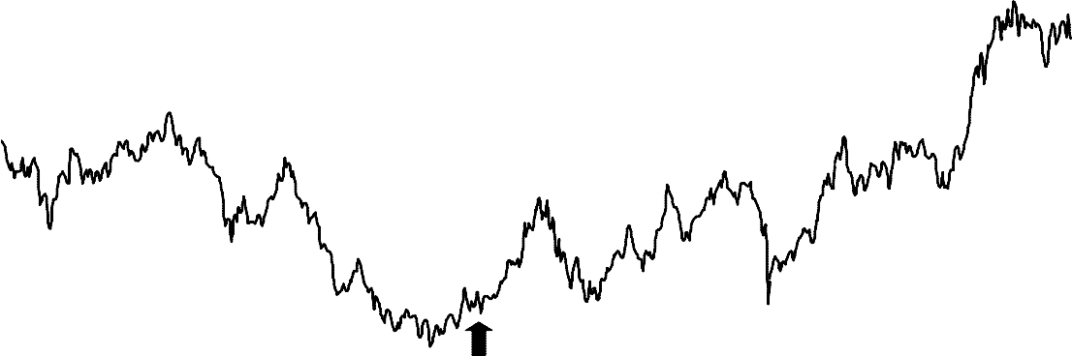
30
Renault - Nissan Alliance is formed - March 27, 1999

25

20

15
Stock Price

10

5

0

Date
6-Jan-95
5-Jan-96
3-Jan-97
2-Jan-98
8-Jan-99
7-Jan-00
5-Jan-01
4-Jan-02
3-Jan-03
2-Jan-04
2-Apr-04

Nissan Motor Co., Ltd. - NSANY

Source: Yahoo! Finance

Exhibit 4

NISSAN MOTOR CO., LTD.
(Consolidated Financial Information)

(Billions of yen) | FY 2003 | FY 2002
Net Sales | $ 3,480 | $ 3,419
Operating Income | $ 246 | $ 316
Ordinary Income | $ 2,280 | $ 293
Net Income | $ 81 | $ 73
Net Income per share (Yen) | $ 18 | $ 16
Year End Dividend per share (Yen) | $ 11 | $ 10
Capital Expenditure | $ 118 | $ 100
Depreciation | $ 60 | $ 53
Total Assets | $ 4,056 | $ 3,934
Shareholders Equity | $ 1,710 | $ 1,799
Equity Ratio (%) | 42% | 46%

Source: Annual Reports.

Exhibit 5

NCI’S VEHICLE ORDERING PROCESS

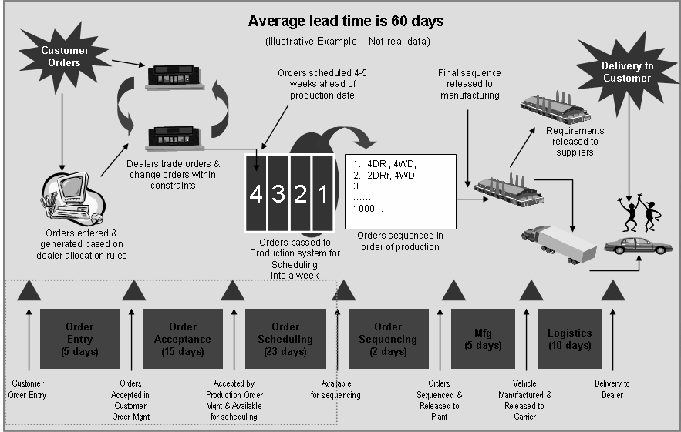

Source: company records.

Exhibit 6 MANUGISTICS SUPPLY CHAIN TOOLS

DEMAND PLANNING

Manugistics’ Demand Planning solution predicts and shapes consumer response by building a business strategy that incorporates forecasting and promotional impacts into the demand plan. This enables users to predict consumer demand in an environment that has more SKUs, channels and product choices than ever before.

DEMAND FULFILMENT

Manugistics’ Demand Fulfilment solution reduces stock-out and improves inventory turns by aligning supply with demand throughout the entire network. It allows users to plan and control the entire supply picture — from determining optimal material and product quantities from suppliers, to planning and scheduling manufacturing, to replenishing and optimizing inventory throughout the distribution network.

ATTRIBUTE BASED PLANNING

Manugistics’ Attribute Based Planning solution is an attribute-based, constrained, bucketed planning system. It plans orders searching for a time when all constraints that apply to an order can be satisfied. Constraints are modelled as capacities on buckets. It searches constraint buckets to find a feasible time, when no hard constraints are violated. If it cannot plan the order when it is needed, ABP uses algorithm rules to search for an alternative time.

Source: Manugistics company website.

Exhibit 7 PLANT FLOW CHART

Net Demand for all compounds is monthly production requirement for NCI

Plant
Production requirement

Compound 1

Compound 2
Sales Forecast based on 3 yrs of sales history

Source: case writer.
Compound & Pipeline inventory is subtracted from Net Dealer Demand to calculate Net Demand at Compound

Dealer A

Dealer B

Dealer C

Dealer D
Dealer inventory subtracted from Demand to calculate Net Dealer Demand (52 Days of Supply)

